# Teleoperate the UR5 by keyboard in Rviz

# 1 [Task Summary]

Here we got a UR5 model and configuration file. Now we expect we can control the robot through keyboard input. We are going to use create a function named **getKey()** to read the input from keyboard and use the **shift_pose_target()** function to move the end effector(Here is the ee_link without true robotiq85 gripper).

# 2 [Process]

All the steps here are imitating the **teleop_twist_keyboard.py**

<https://github.com/ros-teleop/teleop_twist_keyboard.git>

## **Step 1:** Modify the **ur5_joint_limited_robot.urdf** file to add a joint limitation for shoulder_lift_joint in case it crash the ground.

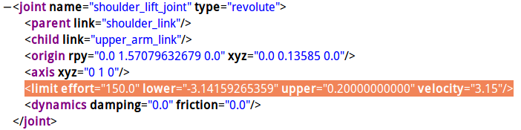

## **Step 2:** Configure your own UR5 configuration file.

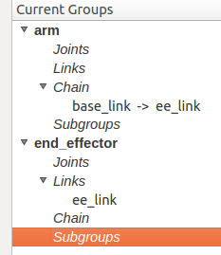

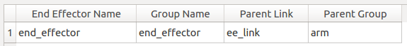

These are the groups and end_effector we create manually.

**Step 3:** In the script file, we need to create a function getKey() to get the input from keyboard.

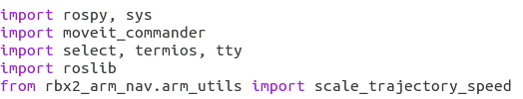

Here are the classes we import.

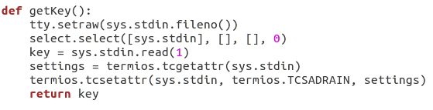

Here is the getKey() function’s definition.

## **Step 4:**Define which key we are going to use for control our robot.

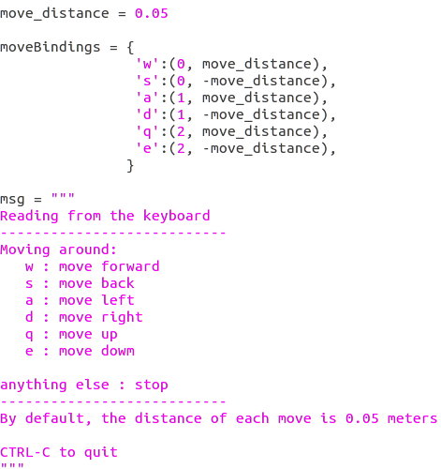

We use “w, a, s, d, q, e” to control the end_effector. At the same time, we create a message which will appear in the terminate screen to guide people control robot.

## **Step 5:** Use a loop and shift_pose_target() to move robot by keyboard input.

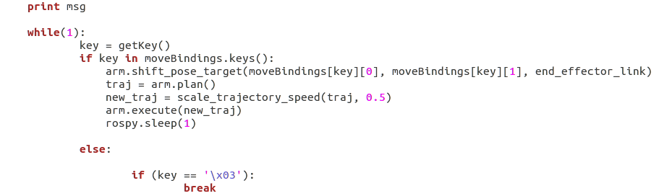

Now we can move the end_effector by keyboard.

# 3 [Problems & Solutions]

**3.1 How to go to the definition of the imported classes or function?**

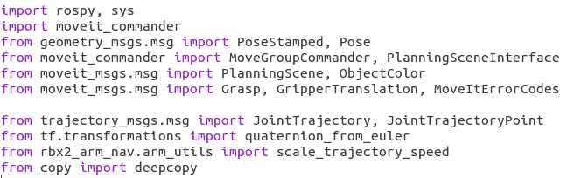

Here is an example, the functions and classes we import have some unknown details for us. I wonder how to go to the definition of each part we import.

**3.2 I still do not know the system how to figure out the trajectory solutions, which means I don’t know which .cpp or .py file I have to go through to pick out the proper trajectory solution.**

**3.3 I do not know how to print the current joint angle or position in the screen. Do we need to create a function or directly subscribe the topic.**